Name: _______________________________________ Date: _________________

HAIKU
A haiku is a form of Japanese poetry, which does not have to rhyme. The first line has 5 syllables, the second line has seven syllables, and the third line has five syllables.

Winter:

(5)__________________________________________________________

(7)______________________________________________________________________

(5)__________________________________________________________
Spring:

(5)__________________________________________________________

(7)______________________________________________________________________

(5)__________________________________________________________
Summer:

(5)__________________________________________________________

(7)______________________________________________________________________

(5)__________________________________________________________
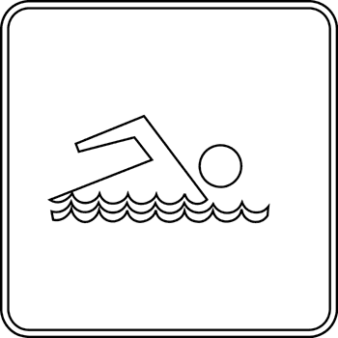

Fall:

(5)__________________________________________________________

(7)______________________________________________________________________

(5)__________________________________________________________
