Using Technology as an Instrument
McKenna Domalski

I cried when Steve Jobs died. I was sitting on my couch, surfing around on my MacBook while listening to my iTunes, my iPhone by my side, when the news broke out on my Twitter Feed.
The technology that Jobs has created has impacted my daily life, since the day I got my first iPod for my 14th birthday in 2004. This man – this innovator of technology – had more impact on my life than some (most) people I have physically met. His death rocked the entire nation, and I couldn’t help find it interesting how truly upset I was, as well as many others, that this stranger was dead. Through the use of his products, Steve Jobs has become a representation of the values that our society places on new technology, specifically American Generation Y and those who follow. Jobs is not the only representation, of course – Bill Gates and Mark Zuckerberg have also become household names, and much more recognizable than Harper Lee or Nathaniel Hawthorne. Since technology has become so integrated into our lives, especially the lives of American youth, why then, is technology so underutilized in American classrooms? English teachers, English being a core class that allows the most imaginative, left-brained freedom, should be jumping at the bit to incorporate technologies into their curriculums, for creating these new literacies can allow students creative outlets that they haven’t yet employed in school. Not only does technology encourage artistic freedom, it proves to be a lot more exciting and engaging than the standard methods of teaching that I myself grew up with, and continues to be used in many classrooms today. Technology needs to be integrated into and utilized in English classrooms, as a medium for content, as well as a source for students’ own academic growth and expression.

I’m from Algonac, Michigan, a middle class region with a population under 5,000. I attended Algonac High School from Fall 2004 through Spring 2008, with a graduating class of approximately 130 seniors. None of my English teachers, throughout all four years of my academic stint, used so much as a Powerpoint presentation in the classroom. The only exposure to “technology” was the occasional movie viewing, after reading the correlating novel (such as when we read The Crucible), or as filler when we were supervised by a substitute. We were granted library time for the occasional research paper, in which it was our choice to use a desktop computer, or one of the few laptops our school had to Google information. The first three years of my English experience in high school were full of dry books and repetitive papers, taught by teachers who did the bare minimum. My senior year British Literature class was the only English classroom where I found the teacher engaging and entertaining enough to consider my time in the classroom a positive and informative experience, and I can’t help but view my first three years of high school English as a waste of my time and energy. Here’s the issue: I LOVE English. I love reading, I love writing, and I love talking about those things. If my English teachers couldn’t even absorb my attention, how could they have possibly reached those who came into the classroom disliking literature and writing to begin with? They didn’t.
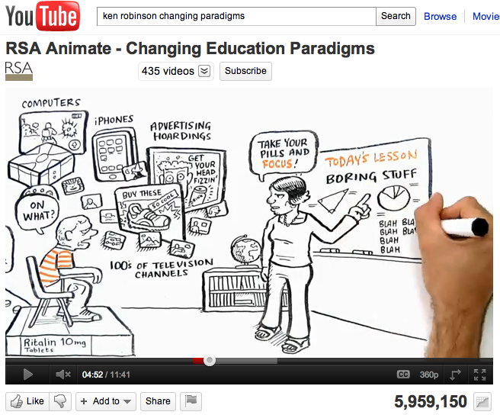
To be quite honest, I didn’t give the idea of incorporating technology into the classroom until very recently. My revelation occurred one day while sitting in class my senior year of college, when my class was shown a remarkable YouTube video. Sir Ken Robinson, author and international advisor on education, examines this “problem” of youth being “hard” to reach at the annual American TED (Technology, Entertainment & Design) Conference, in which his insight was recorded, and is now available to and should be utilized by all educators on YouTube. Sir Ken explains, “Our children are living in the most intensely stimulating period in the history of the earth. They’re being besieged with information and called for their attention from every platform… computers, from iPhones, from advertise hoardings, from hundreds of television channels, and we’re penalizing them for getting distracted. From what? Boring stuff… at school, for the most part,” (YouTube). When watching this, I suddenly realized how ridiculous it is to attempt to fight technology, and how silly it would be not to take advantage of such a useful tool in the classroom. Personally, I’ve always responded more to visually stimulating lessons in any subject, especially in comparison to being talked at. Videos, computer based programs and presentations, and music have always captured my attention more so than lectures, which is true of most students, and understandably in today’s world. Teachers are now often competing with technology; cell phones, video games, movies, iPods, social networking sites… the availability of technology today is virtually endless. Teachers are passively disengaging from their students by the refusal to integrate methods into the classroom that would be beneficial to the learner. So why are they doing so?
Why technology ISN’T being used in English classrooms…

Technology is intimidating. It’s always changing, and quite frankly, it’s hard to keep up with. Even today, Powerpoints are becoming old, boring technology, just as the overheads before them, and the whiteboards before that! Technology is moving faster than the older generations choose to keep up with, creating a huge gap between student and teacher. This is a problem. The roles of teachers are becoming more involved, and more complicated, for there is a need and expectation to cater to what the students know, and will respond to. Author Sara Kajder concurs, for her research states, “Technology integration absolutely requires change in the role of the English teacher. Not only do we need to work to facilitate student learning, but we also need to work to develop both our digital literacies and those of our students. In order to construct challenging curriculum and standards based activities that effectively integrate technology into English instruction, teachers need to work as instructional designers. In this capacity, teachers become resource managers, juggling electronic files and resources, hardware and networks,” (Kajder 1). In order to promote digital literacy, a teacher must be digitally literate as well. Of course, this is easier said than done. Technology is constantly evolving, and the older generations seem to be intimidated, and thus, out of the loop. As teachers, there was a conscious decision to work with youth, thus comes the responsibility to continually keep up with the trends of younger generations. We have to learn to speak students’ language, even if it’s out of our own comfort zone.
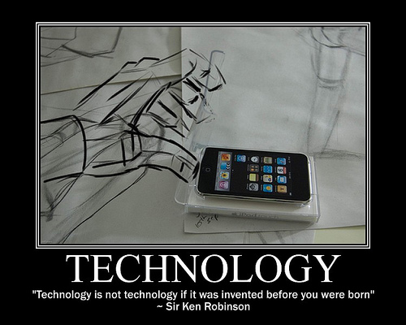
There is also the belief that technology is not a positive addition to the classroom, or even to our daily lives. It is hard to envision this ideal, but Ewa McGrail, professor at Georgia State University, interviewed English high school teachers in 2005 and found negative connotations. She reported, “These teachers blamed computer technology, especially games, for moving students away from literature, defined by them as book-based culture, to what they called a leisure-based culture, where reading, writing, and literature exploration were portrayed as difficult rather than attainable tasks. At the same time, these teachers were eager to obtain further support and training in technology, for they saw its potential to motivate the less able or to promote interactivity in English.” (McGrail 1). Teachers are, and have been, blaming video games and television shows for taking up time that could otherwise be spent reading or writing. Instead of working with technology, and attempting to incorporate that kind of enthrallment in their classroom, teachers often dismiss it as useless or problematic. McGrail also reports of the surveyed teachers, “They believed that their students were losing their social skills as a result of frequent interaction with computers in and outside school. Despite these differences in attitudes, the majority of the teachers acknowledged the changing nature of their discipline as a result of information technology. They admitted, however, that they still needed to rethink what learning to read and write means in a technological age.” (McGrail 1). Teachers do see the value, but it seems as though they don’t always find the opportunity to be trained or to learn the information on their own. Considering the possibility of technology isolating students socially, which is a schema that can be combated in the classroom, by asking students to use their beloved technology to combine and relate texts to what they already know and are familiar with. The emergence of digital and technological literacy is erupting whether we want it to or not, and English teachers aren’t always rising to the occasion.
Even if teachers are eager and willing to incorporate these new technology literacies into the classroom, there is always the question of that being a financial option. While observing to become a certified teacher, I have sat in a twelfth grade English classroom in which students read aloud, day after day. When inquiring as to why the lack of technology, my mentor teacher, Mr. “Barker”, informed me that the school didn’t have the resources. He was informed that the school had ordered the teachers projectors that could be hung from the ceiling, but until then, the only sign of the past two decades is the DVD player that is connected to the box TV. He was also provided with iClickers, a tool to survey students then immediately and anonymously project their results upon a screen. Being that there was no projector, there was no use for the one technology resource Mr. Barker was allocated. Mr. Barker was eager to use Powerpoints, or show videos from YouTube and other video hosting sites, but he had no way to physically display that and have it seen by the class. There is desperate need for the administration to change. More value needs to be placed on the beneficial aspects of technology, so grants can be written or more money can be allocated to investing in new technological resources. There is not enough of an attempt to find ways in which to reach students who are not normally engaged in school, and thus many students are being left behind.

Why technology SHOULD be used in English Classrooms…
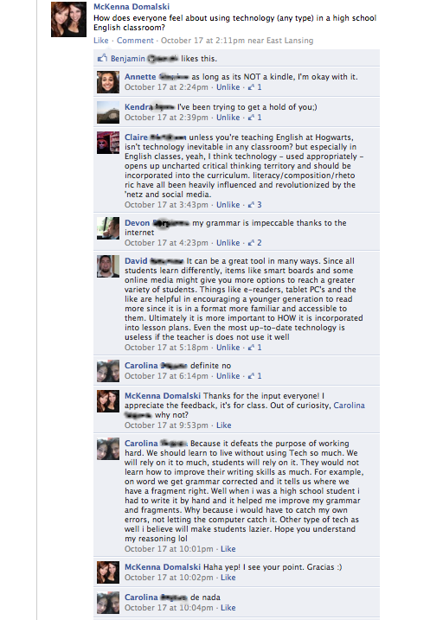
When thinking about using technology in the classroom, it’s important for teachers to relate to their students, and remember their own time as a student. There is a large movement towards meeting standards that determine how adequate a student’s ability to read and write, but other literacies, such as digital and technological literacies, are being left behind. As noted by researcher Donna E. Alvermann, “It’s almost ironic that, at a time when young people are becoming credible consumers of mass media and popular culture, curricular standards and pedagogical practices move further from real-life engagements with media to more traditional approaches to teaching and learning,” (BPR 19). Teachers should be working parallel to technology… in cahoots with it. Younger generations are attracted to the face paced, visually and mentally stimulating presentation, so that’s exactly how we should feed information to students. I would have loved to have had my teachers teach using programs such as Prezi or iMovie, or to have even have had that option to present my own literary information if formats such as those. Engaging students is the most important part of a teacher’s job, and it is up to us to ensure that happens. When I decided to pose this question to my fellow FaceBook-ers, I got interesting feedback. Majority of the respondents (all between the ages of 19 and 25) felt that technology should be used as a tool in the classroom. We as teachers should be taking into consideration what students want, and more importantly, what they respond to. Only one respondent (out of the five who responded with relevant answers) felt that technology should not be used. As can be seen and read in my present FaceBook post, Carolina, the only student against using technology, had the poorest written response. She writes, “Well when i was a high school student i had to write it by hand and it helped me improve my grammar and fragments.” It seems as though technology should perhaps be used as a tool, because it not only encourages engagement, but can also be used as a tool to improve writing and practice reading.
Alvermann describes current teachers (and the older generation) as “Digital Immigrants”, and students and youth as “Digital Natives”. Teachers seem to fall into a rut, almost understandably. Of course it’s easier to walk into your classroom and simply discuss the themes 1984, than to prepare a Powerpoint or Prezi with video and audio clips. Alvermann explains, “Unfortunately for our Digital Immigrant teachers, the people sitting in their classes grew up on the ‘twitch speed’ of video games and MTV. They are used to the instantaneity of hypertext, downloaded music, phones in their pockets, a library on their laptops, beamed messages and instant messaging. They have little patience for lectures, step-by-step logic, and ‘tell-test’ instruction,” (BPR 20). As Alvermann has found, technology may be the only way to reach some students, especially when giving them their own freedom on class assignments and projects. As a fellow teaching student pointed out to me, high school students often have a more personal investment in creative projects, especially those that can be shared on the internet, for they have the capability to reach a much larger audience. Michigan State University professor Julie Lindquist uses the term “multimodality” when pushing for the use of technology in the English classroom. Lindquist defines, “Multimodality -Using several modes at the same time to create meaning, such as combining language, images, color, sound, and/or music, as is often done for multimedia presentations” (Lindquist 186). Giving students the opportunity to multimodal encourages success, both in and out of the classroom. It is a promotion of creativity, as well as creating technologically literate students thus promoting their future as college students and opening up career options. Using technology can encourage classroom involvement, even if English is not their favorite subject, as well as helping provide students with tools they can use in any subject area, as well as their future.
A students’ knowledge of technology can also influence their entire future, whether that is in college or in the job market right out of high school. Lindquist found that, “In 2007, typical jobs ads for writer and editor positions roughly equivalent to the jobs of 20 years ago often required a working knowledge of several digital design programs. A typical job as a proposal writer and marketing associate for an international firm demanded not only experience in Microsoft Office programs but also design programs like Photoshop, Illustrator, and Quark Express.” (Lindquist 176). Technology is not only becoming part of the younger generations lives as entertainment means, but also as apparatus for stores and businesses and companies to run and be efficient. The part-time job I hold now for my own college expenses require that I have a knowledge of Microsoft Office, as well as being able to handle emails and web data. Introducing students to new technologies and drawing on from what they already know can be a determinant in a student’s future.
Not only does technology benefit mainstream, Native English speaking students. English as Second Language (ESL) learners can also profit greatly from the use of technology, perhaps even more so than those who speak English as their first language. Jan Lacina, researcher and former teacher herself, strongly advises the use of technology in English classrooms with students speaking mixed languages. She states, “As with teaching mainstream students, no one technology is better suited for using with ESL students than others. It is most important, however, to choose technology that increases student interactivity. The Web offers many opportunities for such instruction, from Web-based pen pals to discussion boards” (Lacina 1). Programs such as Reader Rabbit and Rosetta Stone can be used as a fun way to teach non-English speaking students our language, allowing them to move at their own pace and have fun while doing so. There is no end to the possibilities available to use technology when teaching ESL students, though many teachers seem unaware of the opportunities present. Lacina writes, “Today, a plethora of Web sites and software packages are designed specifically for English language learners, and not only are most teacher candidates well-versed in how to use technology, they are likely familiar with numerous software programs that are appropriate to use with children. Although teacher candidates may be well-trained in how to use technology, they are often unfamiliar with software and techniques for working with English language learners who may be enrolled in their regular education classroom“ (Lacina 1). English teachers have an obligation to learn about technology, so they can benefit all their students, presently, and for the future.
So… now what?
How can we, as future teachers, and current teachers, address this problem? Firstly, teachers must take responsibility in becoming digitally literate. We must be able to understand the technologically available and upcoming, in order to relay that information to our students. This, of course, is not a full proof system, for it seems that there is an unwritten rule that youth is always at the forefront of the technological advances. There is an awesome opportunity for teachers to learn from students, which is beneficial to both parties. Knowing what is out there is the first step, and then becoming familiar with those opportunities is critical. Teachers, particularly English teachers, must always be open using new technology, to engage their students. As has been reiterated throughout research, students are surrounded by a colorful, stimulating world, and that should be replicated in the classroom. Learning is possible through the usage of technology, and quite frankly can be more fun that way. I’m not calling for the dismissal of lectures or class reading, but adding technologies, such as Prezi, iClickers, iMovie presentations, internet memes, music, YouTube videos, etc., can be vital and influential in students’ success.
Teachers desperately need to adapt to the time period in which they teach. This of course, is easier said than done, as I myself am unaware of all the technological options available and beneficial to use in a classroom. As I began to consider this topic, my fellow future teachers and myself realized, we ourselves haven’t been taught practical uses of technology to use, especially in an English classroom setting. But, as Kajder states, “As teachers, we are used to making choices. We choose the texts that we want our students to enjoy and to explore. We choose the challenges that we want them to experience as writers. With the continued introduction of increasingly powerful technologies into our classroom spaces, we must now learn how to choose the most efficient and effective tools for our student learners,” (Kajder 1). In this day and age, the question of how to engage our students is critical, especially when some many are getting left behind, contrary to what Congress attempted to prevent. Would you, as a reader, like to reread this paper, or watch a movie version instead? …Exactly. I’m not saying to dismiss reading and writing and discussion, because that’s not what technological advances are asking us to do. As Lindquist states, “In terms of the cultural and political aspects of literacy, the emergence of digital technologies makes much more visible a wider range of choices in design and medium. This range of choice makes us more conscious of the limitations of choice and control with the printed page (such as this one)” (Lindquist 204). Technology can help us teach… not do the job for us, nor replace the content that we are teaching. In an interview, Steve Jobs once said,
“Remember in the Sixties, when people were raising their fists and saying, ‘Power to the people’? Well, that’s what I’m doing with Apple. By building affordable personal computers and putting one on every desk, in every hand, I’m giving people power. They don’t have to go through the high priests of mainframe – they can access information themselves. They can steal fire from the mountain. And this is going to inspire far more change than any nonprofit”.
At first I was really aggravated by what Jobs seemed to be implying, but after giving it some thought, I saw the validity in Jobs’s idea. He wanted to empower people by giving them knowledge, therefore changing their own lives, and quite possibly, changing the world. He wanted to, and did, reach millions of people across the globe, by handing them a technological instrument to create their own change. That is exactly what we have to do as teachers… and I plan to.

